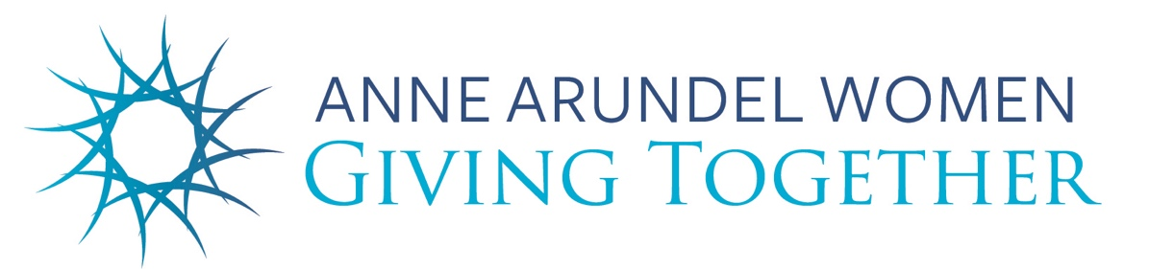

Resource List for Nov. 15 AAWGT Education Program on
School Readiness

- https://www.aacps.org/earlychildhood
- https://www.aacounty.org/partnership-for-children-youth-and-families
- https://www.cfaac.org/needs-assessment.html (Poverty Amidst Plenty VII)
- www.aacpl.net/kindergarten
- 1000 Books Before Kindergarten
- Community pantry (at Discoveries: The Library at the Mall)
- https://aaccaa.org/early-head-start/
- https://www.readyatfive.org/
- https://www.zerotothree.org/issue-areas/early-learning/

H.R. 5894, the House FY24 Labor, Health and Human Services, Education, and Related Agencies Appropriations Act that was mentioned during the program has been pulled temporarily. But please continue to advocate for it. Learn more here: https://nhsa.org/take-action/?vvsrc=%2fCampaigns%2f103764%2fRespond

