Challenges and barriers for military and veterans
Sexual assault and discrimination among the biggest obstacles women face in the Armed Forces
Military and veteran women face serious challenges and discrimination

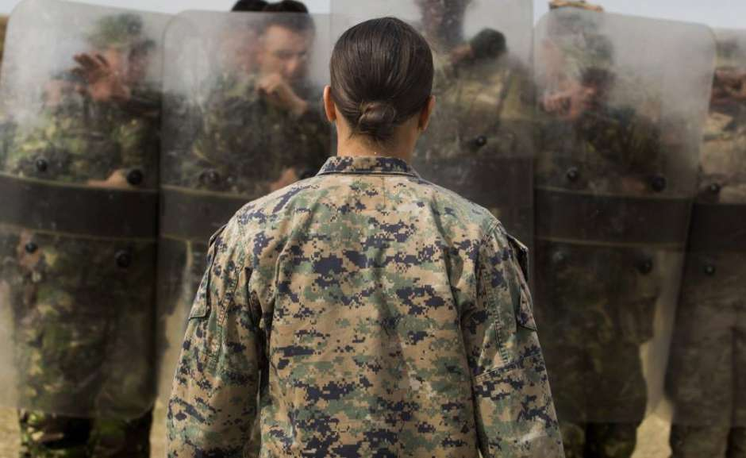.
By: Virginia Gaglianone June 28, 2018
"I would do it all over again. Definitely having served in the Navy gave me a different perspective in life, "said Magdalena Sánchez, a Latino veteran from Tucson, Arizona, who retired from service in 2005.
In an interview with this newspaper, Sanchez recalled many of the good moments of his years of service, such as meetings on Saturday night on the ship.
"Mexicans, Colombians, Cubans ... people from all over the world joined us as a great family, we could relax and be ourselves", shared the veteran.
But at the same time, Sánchez acknowledged that there are still many challenges and obstacles for military and veteran women, particularly for women of color.
"There is a deep-rooted mindset of 'Así se las cosas' - “Deal with it”, he explained. The veteran indicated that in the Armed Forces, many times they see women who try to raise their voices and talk about certain issues, such as sexual assault or discrimination.
"Many people prefer to look the other way, ignore the problems that do exist. During the years that I was in the Navy, I did not see that there was a change of mentality, "he said.
"Women have always contributed and fought alongside men , "said Antonieta Rico, Director of Communication and Policy for SWAN, a non-profit organization that advocates for the rights of serving women in service and veterans.
A study conducted by SWAN in 2016 on the needs and challenges of women in the Armed Forces found that the three biggest challenges that women face in service are bias and prejudice based on gender, family policies and sexual assault.
On the other hand, the biggest barriers between veteran women who are no longer in service are coverage and access to health care, issues related to mental health and difficulties navigating the VA system (Department of Veterans Affairs).
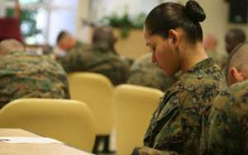

Sexual assault
One of the biggest challenges reported was the sexual assault and the lack of consequences for the perpetrators.
"70% of women, and also men, although on a much smaller scale, report having received both professional and social reprisals after reporting cases of sexual assault; while the perpetrator remains in the service, and even receives a promotion, "said Rico.
Only 4.1% of cases of sexual assault result in the conviction of the perpetrator.
#MeToo in the Armed Forces
The Department of Defense's report on sexual assault in the Armed Forces found that in fiscal year 2017 there was a 10% increase in assault complaints, and yet, the number of cases that went to trial and sentences decreased. Rico explained that in military justice, civil justice is conducted differently.
When a woman, or man, is a victim of sexual assault, you must first report it to your supervisor. In many cases, the assault was committed by the same supervisor or a friend of the same. The decision to initiate or not an investigation in this respect is of that supervisor.
Each year since 2013, Sen. Kirsten Gillibrand of New York introduces the Military Justice Improvement Act proposal in the Senate , but has so far been rejected.
This amendment would require a change in the steps that follow a sexual assault complaint, and that a criminal investigation be initiated after the complaint, among other requirements.
"The participation of women is critical in the Armed Forces and an aggressive change is necessary to eradicate sexual assault and discrimination," Rico said.
Six years ago, the documentary "Invisible War" (The Invisible War) exposed the problem of sexual attacks in the Armed Forces. The women interviewed assured that little has changed since then.

Personal challenges
"When I retired, I found it difficult to adapt to my new life, to find my place among the civilian population, " shared Sánchez, who is the mother of an 8-year-old boy. The veteran said she had expected to have children until after retirement.
"I have a friend who had to live far away from her children and I saw how hard it was for her not being able to be with her children. It is very difficult for mothers who are in service, "he explained.
The women surveyed for the study also highlighted problems of financial stability and connection with other military women and with the community in general, once they try to reintegrate into civilian life. 9% of the total number of veterans and 15% of the people in service are women.
Rico gave examples of women who came to the Department of Veterans who were asked, "Where is your husband," and shared examples of members with unambiguous names of women whom they called "sir" instead of "lady."
Regarding the causes of the culture of discrimination, sexual assault and lack of integration, Rico highlighted the institutional culture that exists in the Armed Forces.
"We have a long way to go to be treated with the same respect as men, especially women of color," Sánchez agreed, referring to promotion opportunities and discrimination in general in the Armed Forces.

